**System Design Document**

**I. Introduction**

This document will provide a comprehensive overview of the Triceratops Browser’s design. This document outlines the architecture, the class and object models, system interactions, and specific methods for implementing the system. It is created to guide developers and team members in understanding the system's structure and behavior before proceeding with the implementation phase. The purpose of this document is to ensure all components of the system are well-defined, and that the development process is efficient and clear.

**Contents of the document:**

* Overview of the system design process
* Refined Class Diagrams with pseudocode
* Statechart Diagrams that depict the states of objects in the system
* Sequence Diagrams that detail the flow of interactions between components

**II. Design-Level Class Diagrams**

1. Class Diagram

Pseudocode:

class SearchManager

String searchTerm

List searchResults

executeSearch() returns List<Result>

combineResults() returns Result

class Result

Int typeSearch

String resultID

String resultData

formatResult() returns resultData

class AISearch inherits SearchManager

String apiEndpoint

Int tokenLimit

sendQuery(query : string)

handleResponse() returns Result

class StandardSearch inherits SearchManager

String searchEngine

sendRequest(query : string)

parseResponse() returns Result

class LocalSearch inherits SearchManager

List fileIndex from fileMetaData

indexFiles() returns void

searchFiles(query : string) returns List<Result>

class systemSecurity inherits LocalSearch

String encryptionKey

encryptIndex() returns void

validatePermissions() returns Boolean

class UserFeedback

String feedbackID

submitFeedback() returns Boolean

**III. Statechart Diagram**

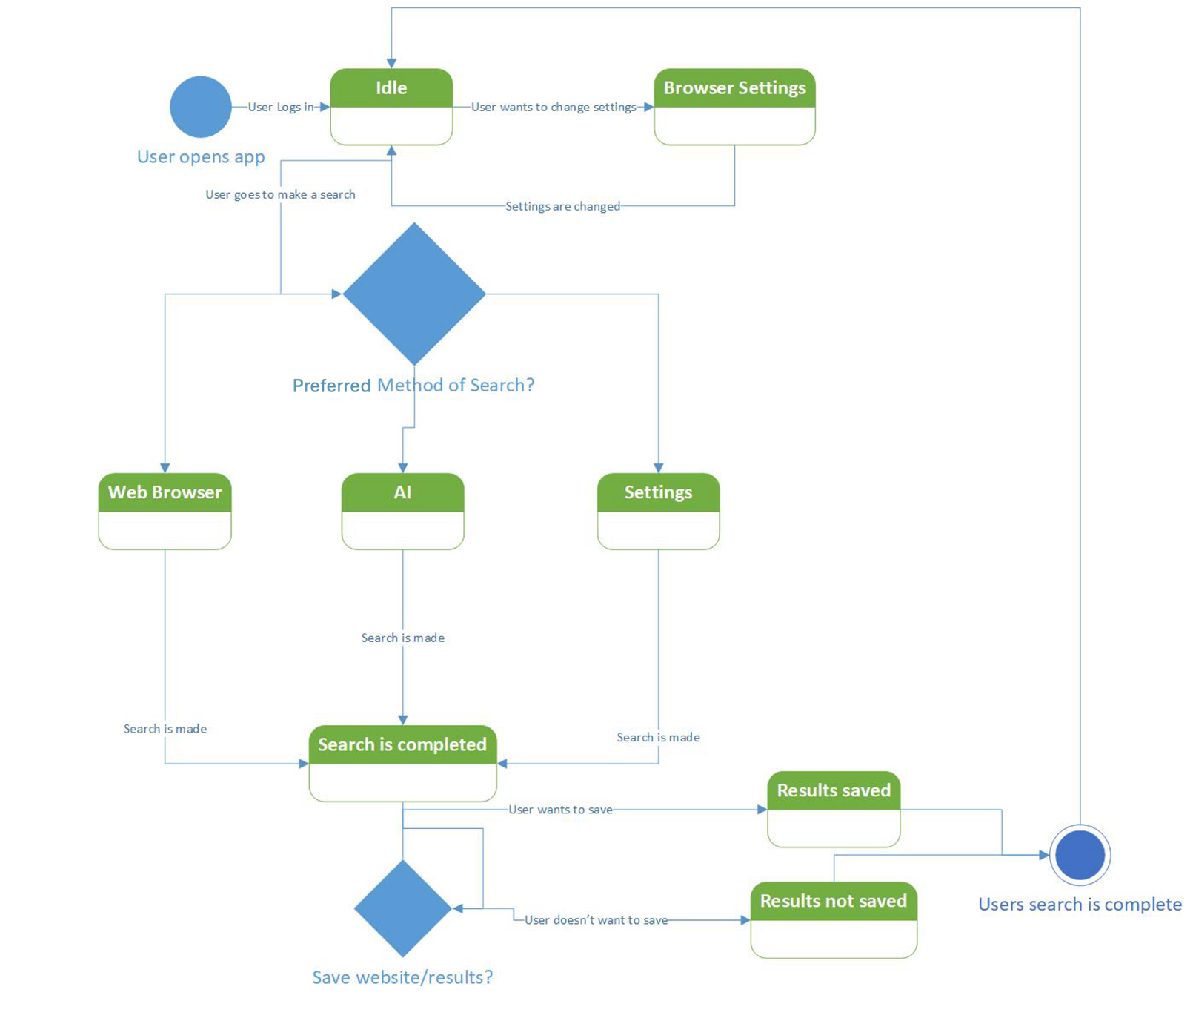

**IV. Sequence Diagram**

**V. Conclusion**

This System Design Document demonstrates how the Triceratops browser app works. The purpose of this document was to ensure that all team members understand how our application functions and what has been done to make it work. This is essential if changes ever need to be made.